**Lab1 report**

**Group 39:**

**Yucheng Chen, Sky Jiang, Haoxin Zeng**

Github: <https://github.com/uottawa20241seg3125agroup39/lab1_survey>

Website: <https://lab.seg3125.uocourse.skycloud.wang/lab1_survey/>

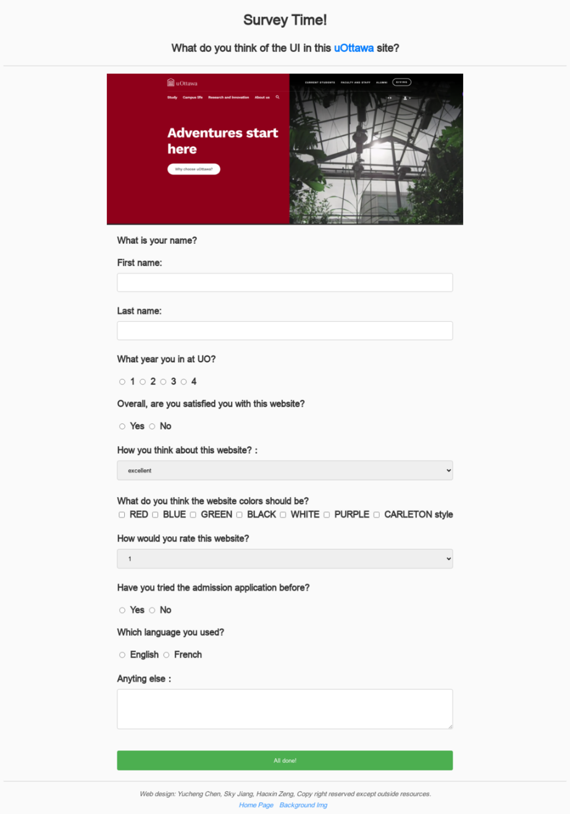

Contributions:

Yucheng Chen:

1. Question design
2. Page 404
3. Basic style initialization

Sky Jiang:

1. Question design
2. Page “submitted”
3. JS code
4. Background setting
5. Github page / DNS configuration

Haoxin Zeng:

1. Question design
2. Page framework initialization
3. CSS design